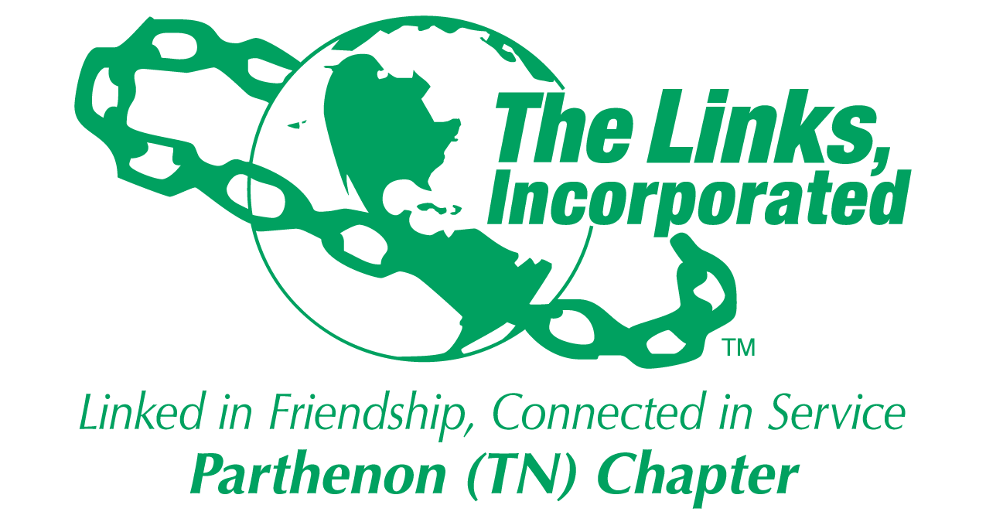
2015-2016 Committees
“I am only one, but I am one. I cannot do everything, but I can do something. And I will not let what I cannot do interfere with what I can do.” Edward Everett Hale

Membership
Jan-Néé Sheats-Mathis, Chair
Virginia McClain
Rhonda Dunn
Cheryl Adams
Simone Sheats
Linda Spears
Karen Shaw
Charlotte Mann
Marcya Carter
Budget and Finance
LoLita Toney, Chair
Peggy Cockerham
Ann Green
Lacie Dunn
Kim Smiley
Sharon Peters
Ann Haynes
Sharon Peters
Public Relations
Harriet Wallace, Chair
Marcya Carter
Carolyn Qualls
Jan-Néé Sheats-Mathis
Genma Holmes

Fundraising and Entertainment
Cathy Bender, Chair
Virginia McClain
Lacie Dunn
Carolyn Qualls
Valencia McShan
JoAnn Davis Davis
Glory Jubilee
LoLita Toney
Wendy Hellum
Pat Bailey
Karen Shaw
Harriet Wallace
Rituals and Protocol
JoAnn Davis Davis, Chair
Ann Green
Carolyn Qualls
Saletta Holloway

Program
Christina Coleman, Chair
Janice Woodard
Pam Scretchen
Gwen Harris
Shindana Feagins
Portia Jordan
Paulette Coleman
Saletta Holloway
Sharon Peters

Bylaws
Paula Coates, Chair
Genma Holmes
Daphne Ferguson
Jan-Néé Sheats-Mathis

Amenities and Courtesies
Veonie McKinnie, Chair
Pam Scretchen
Yvonne Current
Phyllis Cain
Nedra Jackson

Ethics
Sheila Peters, Chair
Carolyn Piphus
Stephanie Bellard Chase

Friendship
Pat Mitchell, Chair
Christie Sheats
Valencia McShan
Marcya Carter
Simone Sheats
Marquetta Faulkner
Ora Bransford
Karen Shaw

Food and Hospitality
Pat Bailey, Chair
JoAnn Davis Davis
Wendy Hellum
Ingrid Collier
Kim Smiley
Veonie McKinnie
Sharon Peters

